Attendee Registration Form for ELEVCON Congress 2021
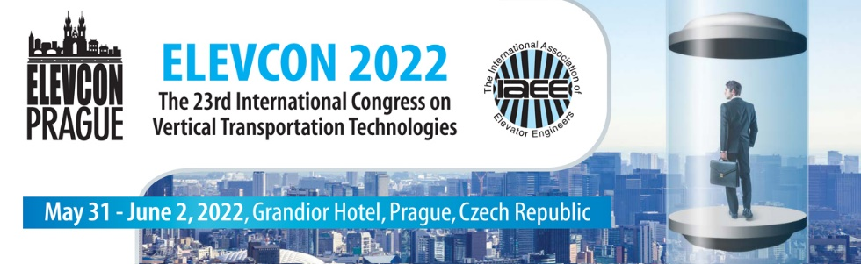
Please send signed form to ELEVCON Secretariat: congress@elevcon.com
Attendee and Company Details:
Surname: Click here to enter text. |  |  | First name: Click here to enter text.
Company: Click here to enter text.

Position: Click here to enter text.

E-mail: Click here to enter text.

Mobile Phone: Click here to enter text.

Phone: Click here to enter text.

Street: Click here to enter text.

Postal code: Click here to enter text. |  |  | Country: Click here to enter text.
Conference Participation Fee
IAEE Member Fee & Speakers Fee:

Early registration until 15.12.2021: €1260.00 |  |  |  | ☐
Late registration after 16.12.2021: €1460.00 |  |  |  | ☐
Non-Member Fee:

Early registration until 15.12.2021: €1360.00 |  |  |  | ☐
Late registration after 16.12.2021: €1560.00 |  |  |  | ☐
Congress Registration Fee Includes: ● 3 days of professional presentations and sessions ● The ELEVCON book of proceedings & congress material ● Congress kit (bag and badge) ● 3 days pass to the exhibition ● Coffee breaks ● Welcome reception ● Daily luncheons ● Social activities.
Terms & Conditions: Payment is due at the time of registration | Cancellation up to 120 days (work days) before the congress, will be charged a cancellation fee of 25% of the participation fee | Cancellation from 119 days up to 60 days (work days) before the congress will be charged a cancellation fee of 50% of the participation fee | Cancellation of less than 60 days (work days) before the conference and/or the event will be charged a cancellation fee of 100% of the participation fee.
We, the undersigned, hereby confirm the above order:
Company stamp | Signature | Name  Click here to enter text. |  |  | Function  Click here to enter text. |  | Date  Click here to enter a date.
Please send signed to ELEVCON Secretariat: congress@elevcon.com
Once we receive the form we will confirm via e-mail

