Guidelines for Authors Preparing Manuscripts for Publication in ELEVCON Proceedings
Aviram Lavy¹, Dovev Koren¹ and Reuma Arav²
¹ESL - Eng. S. Lustig Consulting Engineers Ltd, Israel
²Technion – Israel Institute of Technology, Israel

Key Words: Simulation, dispatching, monitoring, safety

ABSTRACT

These guidelines are provided for preparation of papers accepted for publication for The Proceedings of ELEVCON 2020, the 23nd International Congress on Vertical Transportation Technologies that will be published in the book ELEVATOR TECHNOLOGY 23. These guidelines are issued to ensure a uniform style throughout the book. All accepted papers will be published provided they arrive by the due date and they correspond to these guidelines. Reproduction is made directly from author-prepared manuscripts, in hardcopy form, in A4 paper size 297 mm x 210 mm (11.69 x 8.27 inches). To assure timely and efficient production of the congress book with a consistent and easy to read format, authors must submit their manuscripts in strict conformance with these guidelines.
- MANUSCRIPT
The maximum paper length is restricted to12 pages, including figures and tables. The paper should have the following structure:
- Title of the paper
- Authors and affiliation
- Keywords (6-8 words)
- Abstract (100 – 150 words)
- Introduction
- Main body
- Conclusions
- Acknowledgements (if applicable)
- References
- Appendix (if applicable)
- Biographical Details

Page Layout, Spacing and Margins

The paper must be compiled in one column for all subsequent text. All text should be single-spaced, unless otherwise stated. Typing should be left and right justified.
The margins must be exactly as follows:
Table 1. Margin settings for A4 size paper
Setting | A4 size paper
 | cm | inches
Top | 3 | 1.1
Bottom | 2 | 0.8
Left | 2.5 | 1.0
Right | 2.5 | 1.0
  - Preparation in electronic form
To assist authors in preparing their papers, this style guide for preparing digital version of papers is hereby provided in Word.
  - Length and Font
All manuscripts are limited to a size of no more than twelve (12) and no less than eight (8) single-spaced pages (A4 size), including abstracts, figures, tables and references. The font type Arial with a size of twelve (12) points is to be used.

TITLE AND ABSTRACT BLOCK

Title
The title should appear centered in bold letters, with each word capitalized at the top of the first page of the paper with a size of eighteen (18) points and single-spacing, set to eighteen (18) points spacing before and after (Figure 1).
Figure 1. Paragraph setting for the paper title

The next line, should include the author(s) name(s), centred under the title at fourteen points (14pt), single-spaced. Then, write affiliation including country in upper and lower-case letters, centred under the title at italic fourteen points (14pt). In the case of multi-authorship, group the authors by firm or organization as shown in the title of these Guidelines.

Key Words
Leave one blank line, then type "KEY WORDS:" in bold capital letters, followed by 5-8 key words. Note that ELEVCON does not provide a set list of key words, therefore, include those key words which you would use to find a paper with content you are preparing.

Abstract
Leave two blank lines under the key words. Indent 0.75 cm (0.3 in) from left and right, and type "ABSTRACT:" in twelve (12) points bold Capitals followed by one blank line. Start now with a concise Abstract (100 - 150 words) which presents briefly the general thesis and conclusion of your paper. A reader should be able to learn the purpose of the paper and the reason for its importance from the abstract. Paragraph layout is to be set to twelve points (12pt) after.

MAIN BODY OF TEXT
Type text single-spaced, with paragraph layout set to twelve points (12pt) after (Figure 2).
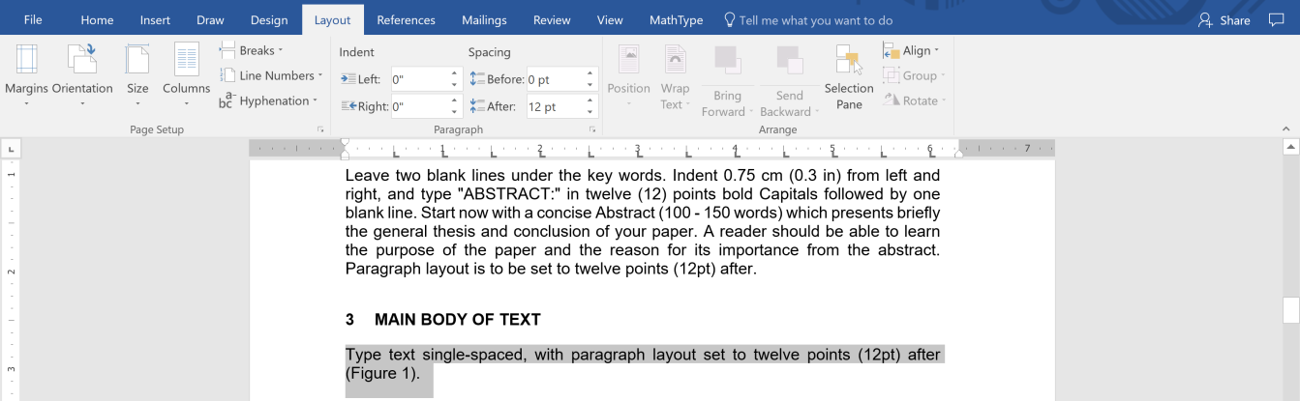
Figure 2. Paragraph setting for the body of the text

Headings
Major headings are to be in bold capitals without underlining, with a spacing of twelve (12) points before and twelve (12pt) after (see Figure 3).
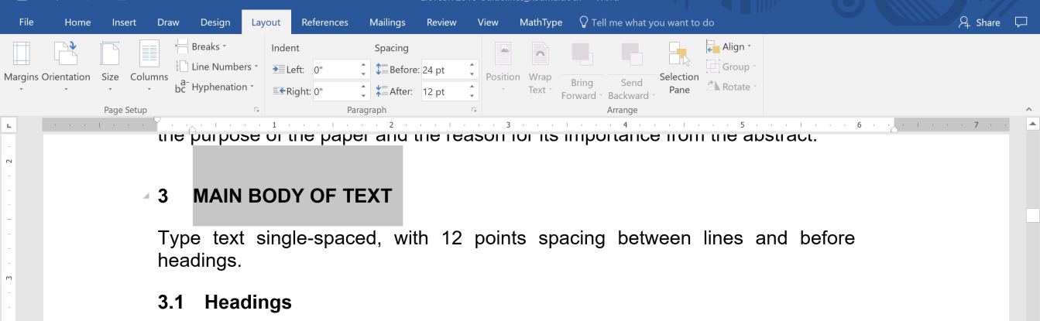
Figure 3. Paragraph setting for major headings
Type subheadings (second-order headings) in bold upper case and lower-case letters. Subheadings are on a separate line with spacing of zero (0pt) points before and twelve (12pt) after (see Figure 4).
Figure 4. Paragraph setting for subheadings
Sub-subheadings (third-order headings) are to be typed in upper and lower-case letters. Sub-subheadings are on a separate line with spacing of zero (0pt) points before and zero (0pt) after (see Figure 5).
Figure 5. Paragraph setting for sub-subheadings
Use decimal numbering for headings and subheadings
No indentation is required for headings.

Footnotes
Footnotes to the text should not be used.

Illustrations and Tables
    - Placement:
Figures, drawings, tables, and photographs must be placed as close as practicable to the reference in the text. Make sure that the figure is either in line with text, or placed within a drawing canvas which is in line with the text, as in the example in Figure 6:
into
Figure 6. An example for a drawing canvas in line with text
    - Captions
All captions should be typed in upper and lower-case letters, in italic, bold and centered directly beneath the illustration, or above the table (see Table 1 and Figures 1-4 for example). Use single spacing if they use more than one line. All captions are to be numbered consecutively, e.g. Figure 1, Table 2, Figure 3.
Photographs: Photographs should be in black and white.
Drawings: it is advisable to use computer drawing software (such as Adobe Illustrator™, Freehand™, Visio™, or drawing tools in MS-Word™) to create illustrations. Do not create labels over shaded areas. Use line thickness of at least 0.3 mm.
    - Copyright
If your article contains any copyrighted illustrations or imagery, please include a statement of copyright such as: © SPOT Image Copyright 20xx (fill in year), CNES. It is the author's responsibility to obtain any necessary copyright permission. After publication, your article is distributed under the Creative Commons Attribution 3.0 Unported License.

Equations, Symbols and Units
    - Equations
Equations should be numbered consecutively throughout the paper. The equation number is enclosed in parentheses and placed flush right. Leave one blank line before and after equations:

(1)

where a, b, c – the normal to the plane
x, y, z – plane coordinates
– vectored annotation for the plane normal
Note to clearly differ between capital and lower-case letters. Avoid confusion between the letter ‘o’ and the numeral zero (‘0’), as well as between the upper case ‘I’ and the numeral one (‘1’). Vectors and matrices in the equations should be clearly indicated.
Variables used in any equations should be defined in the main text where they first appear. If applicable, units of measurement should be given.
    - Symbols and Units
Use the SI (Système Internationale) Units and Symbols. Unusual characters or symbols should be explained in a list of nomenclature.

References
References should be cited in the text, thus (Smith, 1987b), and listed in alphabetical order in the reference section.

Biographical Details
Short biographical details of the authors.
5. CHANGES
Once your paper has been submitted in MS-Word™ (DOCX format) no changes to it can be made. Consequently, please proofread your paper carefully and use spell-checking tools before sending.
6. ADOBE PDF™ FORMAT
Please also submit an Adobe PDF™ format version of your paper. (i.e., the paper should be submitted in DOCX format, and in Adobe PDF™ format).
Papers (DOCX and PDF formats) must be submitted via E-mail only to ami@lustig.co.il
The deadline for the submission of papers is February 15th, 2018. If you fail to send on time, your paper may not be published.
The Adobe PDF™ file submitted must be the paper’s final version and must be identical to the DOCX version that was submitted.
ACKNOWLEDGEMENTS (optional)
Acknowledgements of support for the project/paper/author are welcome.

REFERENCES
Aba, M. B., Pesach, M.M., and Shekel, M. (1998). On the numerical modelling of elevators. Jnl. Transportation Res., Vo1.19 (5), pp.33-41.
Asher, T., Tamar, U.C., and Perez, M.E. (1999). A breakthrough in traffic studies In: Advances in Technology, A .F. Baruch (Ed)., Vol.4, 3rd ed. Academic Press, Ramat Gan, pp. 223-247.
Arav, T. and Tal, C. (1980). Simulation Study. Report for the Givatayim City Council, Keter. 71pp.
Gur, C.P.L. and Lulu, H. (1980). Elevators: Theory and Application. Marcel Tamir, New York. 475pp.

APPENDIX (optional)
Any additional supporting data may be appended, provided the paper does not exceed the limits given above.

Revised August 2019

